PLANNING PROCESS
P
L
A
N
N
I
N
G
P
R
O
C
E
S
S

General Responsibilities 7-2
Planning Cycle 7-4
Planning Meeting Agenda 7-6
Daily Flow of Events 7-10
Incident Action Plan Components 7-11
Forms 7-12

THE INCIDENT ACTION PLANNING PROCESS

The Incident Command System emphasizes orderly and systematic planning. The central tool for planning during a response to a major emergency is the Incident Action Plan. The Incident Action Plan is prepared by the Planning Section, with input from the appropriate Sections and Units of the Incident Management Team. It should be written at the outset, and revised continually throughout the response.

Incidents vary in their kind, complexity, size, and requirements for detailed and written plans. In an initial response for an incident that is readily controlled, a written plan may not be necessary. Larger, more complex incidents will require an Incident Action Plan to coordinate activities. The level of detail required in an Incident Action Plan will vary according to size and complexity of the response. The Incident Commander may direct that a written Incident Action Plan be developed for any incident.

The plan must be accurate and completely transmit the information gathered during the planning process. The plan must be prepared and distributed prior to the Operations Shift Briefing. A plan should be prepared for each operational period. A planning process has been developed as part of the Incident Command System to facilitate the development of an Incident Action Plan in an orderly and systematic manner. The following explains the planning process required to develop an Incident Action Plan. Following the planning steps will allow for the development of an Incident Action Plan in a minimum amount of time.

It is important to remember that the incident management process is occurring on two tracks: Those actions needed to manage the current operational period, and the planning tasks required to prepare for the next operational period.

General Responsibilities

Command
- Provide general incident objectives and strategy.
- Provide direction or overall management and strategy.
- Ensure Incident safety
- Approve the completed Incident Action Plan by signature.

Planning Section Chief
- Conduct the Planning Meeting.
- Coordinate preparation of the Incident Action Plan.

Operations Section Chief
- Determine tactics to achieve Command objectives
- Determine resource requirements
- Determine Division boundaries.
- Determine Division/Group work assignments.
- Conduct Operations Shift Briefing

Logistics Section Chief
- Establish/confirm the procedure for off-incident resource ordering.
- Ensure that resource ordering procedures are communicated to appropriate agency dispatch centers.
- Ensure that the Logistics Section can support the Incident Action Plan.
- Complete assigned portions of the written Incident Action Plan.

Finance Section Chief
- Provide cost assessment of incident objectives.
- Ensure that the Incident Action Plan is within the fiscal limits established by the Incident Commander.

THE PLANNING CYCLE

The Incident Action Planning cycle involves four major phases:

I) Phase 1: Set Incident Objectives

This is done by the Incident Commander. The incident objectives are not limited to a single operational period, but should consider the total incident situation.

The Incident Commander identifies the general strategy to be used, and states major policy, legal, or fiscal constraints in accomplishing the objectives and appropriate contingency considerations.

Setting or re-affirming goals and objectives at the beginning of each operational period is a top duty priority of the Incident Commander, and should observe the following guidelines:

- Objectives must be clearly stated and measurable, so the Incident Management Team can determine how much was accomplished during the current operational period.
- Objectives must be attainable given the resources available during the operational period.
- Objectives must be broad and flexible enough for the Operations Section Chief to achieve them in the best tactical way possible.

Before finalizing the objectives, a draft should be discussed with the Operations Section Chief. The Operations Section Chief should understand the objectives, and confirm that they are achievable and realistic.

After discussion, the draft objectives are documented on the Incident Objectives Form (ICS 202), and delivered to the Command and General Staff so that they will know what the strategy for the next operational period will be, and can prepare for the Planning Meeting.

II) Phase 2: Preparation for Planning Meeting (Command Meeting)

If the incident is being managed under a unified command, the Incident Commanders should meet prior to the Tactics Meeting to agree on a unified incident strategy and general objectives. The Command Meeting is usually attended only by the Incident Commanders, and the following topics should be discussed as appropriate:
- Jurisdiction or agency priorities
- Jurisdiction or agency limitations, concerns, restrictions
- Develop a collective set of incident objectives
- Establish and agree on acceptable priorities
- Adopt an overall strategy or strategies to achieve objectives
- Agree on basic organizational structure.
- Designate the best qualified and acceptable Operations Section Chief.
- Agree on General Staff personnel designations and planning, logistical, and financial arrangements and procedures.
- Agree on the resource ordering process to be followed.
- Agree on cost-sharing procedures.
- Agree on informational matters.
- Designate one IC to act as the Unified Command spokesperson.

Preparation for Planning Meeting (Tactics Meeting)

The Tactics Meeting allows Command, Operations, and Planning an opportunity to fit tactics to objectives prior to the Planning Meeting. While strategy and tactics are sometimes revised as part of the Planning Meeting process, completing some of this work at the Tactics Meeting will facilitate an efficient Planning Meeting. If safety of tactical operations is of concern, it is wise to include the Safety Officer in the tactics meeting.

The Tactics Meeting is facilitated by the Planning Section Chief.

The Incident Commander and the Operations Section Chief discuss and agree upon strategy, and the Operations Section Chief details tactical assignments to ensure that those strategic goals will be met, including identification of the Operations organizational assignments to the Division/Group Level. The Operations Section Chief defines geographic boundaries for Divisions and Branches; these boundaries will be plotted on the incident map for the Planning Meeting. Command and Operations also determine the Operational Period for which the plan will be developed.

The Safety Officer may assist in developing safe tactical approaches to the incident.

The Planning Section Chief provides alternatives and contingency plans and describes their feasibility. Command and Operations select appropriate contingency plans.

The results of this discussion are documented on the Operational Planning Worksheet (ICS 215) by the Planning Section.

III) Phase 3: Planning Meeting

Prior to the Meeting:

- Planning should notify participants of time and place of meeting. Only key personnel should attend the Planning Meeting in order to facilitate an orderly and brief exchange of information.

- Planning should ensure that planning maps, forms, resource and situation status displays are available and up-to-date.

At the Meeting:

- The Planning Section Chief is responsible for conducting the planning meeting and ensuring that the flow of information is brief, complete, and to the point. Most of the groundwork for the plan should have been done by all parties prior to the meeting.

- The Meeting should proceed following the Planning Meeting Agenda below:

Planning Meeting Agenda

Task Primary Responsibility
- Briefing on situation/resource status PSC
- Set incident objectives IC
- Plot control lines and division boundaries OPS
- Specify tactics for each division/group OPS
- Specify resources needed by division/group OPS/PSC
- Specify facilities and reporting locations OPS/PSC/
LSC
- Develop resource and personnel order LSC
- Consider communications/Medical/ PSC/LSC
traffic plan requirements.
- Consider safety issues SO
- Provide financial update FSC
- Consider interagency liaison issues LO
- Consider information issues PIO
- Finalize/approve/implement plan IC/All

1. Briefing on Situation and Resource Status
The Planning Section Chief and/or the Resource and Situation Unit Leaders should provide a briefing on the situation as it currently exists. Information for this briefing may come from any or all of the following sources:
- Initial Response IC
- Incident Briefing Form (ICS 201)
- EOC Staff Briefing Form
- Field Observations
- Operations Section
- Resource and Situation Reports

and should include:
- Status of current tactical assignments
- Resource condition
- Resource shortages
- Major problems
- Projections which may impact the next operational period (weather changes, etc.)

2. Set Strategic Goals
The Incident Commander should confirm or modify the strategic goals circulated in draft.

3. Plot Control Lines and Division Boundaries
The Operations Section Chief will discuss the physical parameters of the incident, including traffic control points, "hot" and "cold" zones, evacuation areas, etc. Where appropriate, these will correspond to Division Assignments and posted to the Operational Planning Worksheet. Boundaries will also be plotted on the incident map.

4. Specify Tactics for each Division/Group
Using the Operational Planning Worksheet, the Operations Section Chief will discuss the tactical assignment for each Division and Group. This should include specific, achievable tactical objectives and alternative or contingency plans. Divisions should be clearly tied to geographic reference points.

5. Specify Resources Needed by Division or Group
The Operations Section Chief, in cooperation with the Planning Section Chief, specifies the resources needed for each Division and Group to achieve its tactical assignment. Planning will confirm whether or not the resource is assigned to the incident and available for the next shift.

6. Specify Facilities and Reporting Locations
Key facilities, staging areas and important geographic locations such as drop-off points, "safe" zones, congregation points, etc. are identified and placed on the map.

7. Develop Resource and Personnel Order
The difference between the resources needed and available in step 5 becomes the resource and personnel order for the next operational period. The Logistics Section Chief compiles these orders, and facilitates the procurement process with the Supply Unit.

8. Consider Communications, Medical, and Traffic Plan Requirements.
The Incident Management Team should assess the adequacy of communications, medical, and transportation/traffic support. If these are deemed to be inadequate, additional resource orders should be placed to ensure that the Incident Action Plan can be supported when implemented.

9. Consider Safety Issues
The Safety Officer will discuss any accidents or injuries, and recommended actions to avoid future mishaps (the Safety Officer may also be involved in step 4-assisting in identifying the safest tactical alternatives). The Safety Officer will develop a written Safety Message which will become part of the written Incident Action Plan.

10. Provide Financial Update
The Finance Section Chief will provide a "cost to date" estimate for the incident, along with any special cost benefit analyses that have been requested. In addition, the Finance Section Chief may report on Compensation and Claims issues such as the status of pending action against the organization, or follow up actions on injuries.

- Consider Interagency Liaison Issues
The Liaison Officer will discuss issues related to cooperating and assisting agencies, including concerns of their management, restrictions on use, etc. This may include requests for release, management issues, etc., which may impact how external resources are used in the upcoming shift. The Liaison Officer may also have information about additional resources available through outside agencies.

12. Information Issues
The Public Information Officer will provide an overview of press coverage to date. In addition, Information staff may have information on the general perception of the media and the public toward the organization which may impact incident strategy and tactics. They may also need to coordinate interviews, visits to the field or the EC, or press conferences.

13. Finalize, Approve, and Implement Action Plan.
Information shared in the Planning Meeting is documented on the ICS Incident Action Planning forms (ICS 202-206). The Planning Section procures the IC's signature of approval, and the Plan is duplicated for hand-off to the Incident Management Team for implementation.

IV. Phase 4: Operations Shift Briefing

The Operations Shift Briefing is the meeting at which the Supervisors of the Operations Section are briefed on their tactical assignments for the operational period. Facilitated by the Operations Section Chief, the Briefing is attended by the Incident Commander, the Planning and Logistics Section Chiefs, the Safety Officer, and other members of the Command and General Staff as needed. The briefing may be conducted according to the following format:

Operations Shift Briefing Agenda

I. Situation Update

II. Review of Plan
This may include last minute "pencil" changes to the Plan, and will include a discussion of each Division/Group Assignment Sheet, including potential contingency plans. Each Division or Group Supervisor will have an opportunity to ask questions to clarify his or her assignment.

III. Discussion of logistical support details
Transportation, communication, medical, food

IV. Review of Safety Message

V. Contingency Planning

The Planning Section will document contingency plans using the ICS 204-Contingency Plan form. The form will be copied in a different color than the rest of the Incident Action Plan, so that it is clear that the contingency plan is not in current use, but so it is readily available to Operations resources in the event it must be implemented.

EMERGENCY CENTER DAILY FLOW OF EVENTS

The graphic below shows the general flow of events and timing for the planning cycle. Times are approximate.

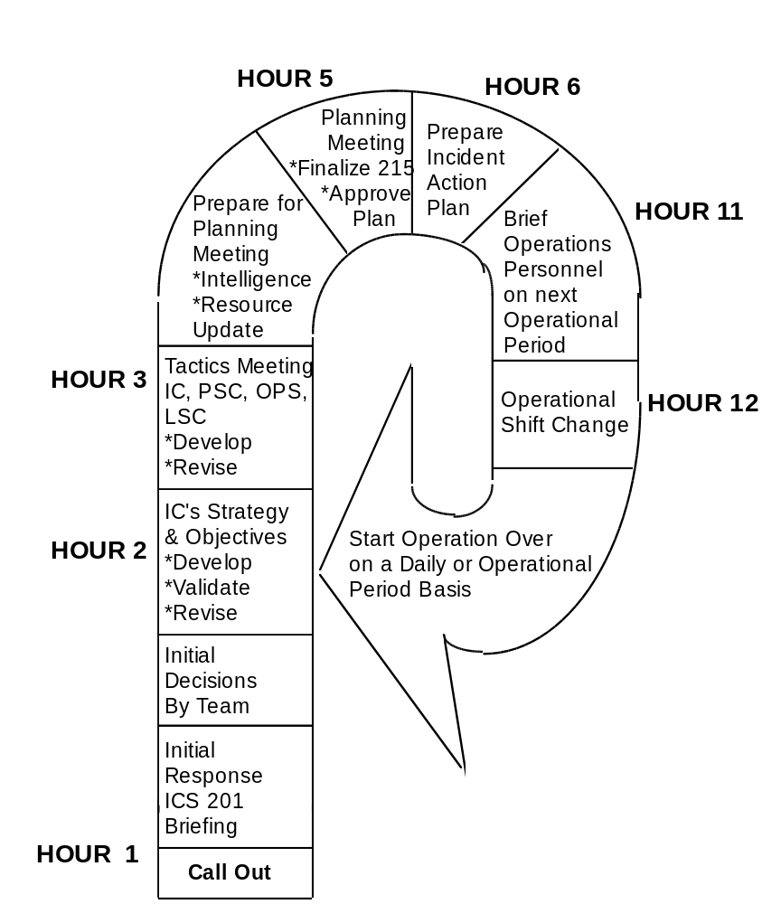
INCIDENT ACTION PLAN COMPONENTS

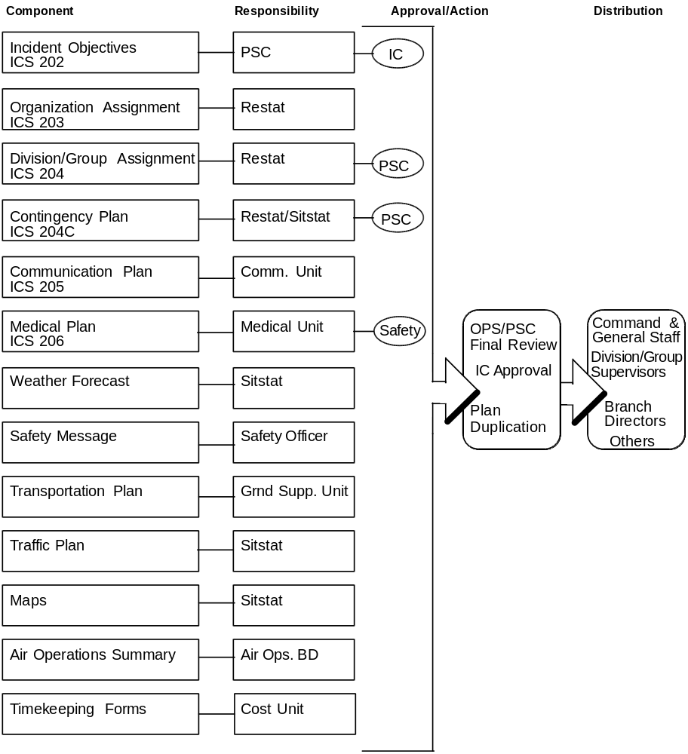

INCIDENT ACTION PLAN COMPONENTS
ICS 202

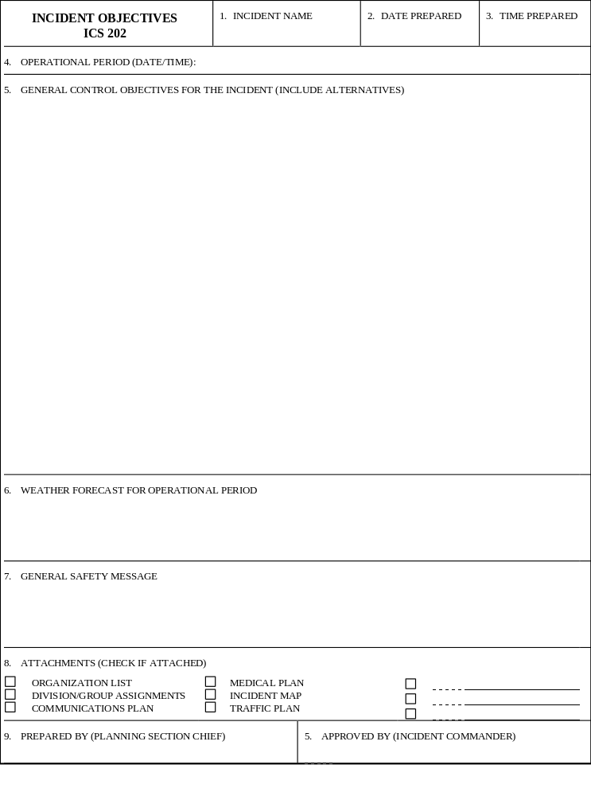

INCIDENT ACTION PLAN COMPONENTS
ICS 203

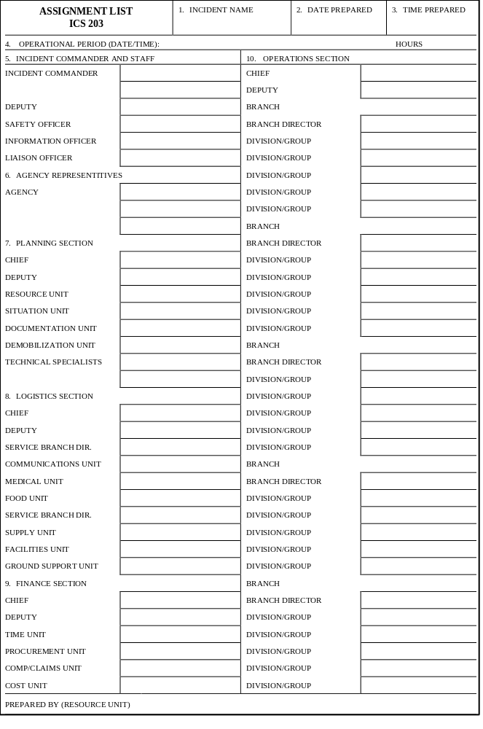

INCIDENT ACTION PLAN COMPONENTS
ICS 204

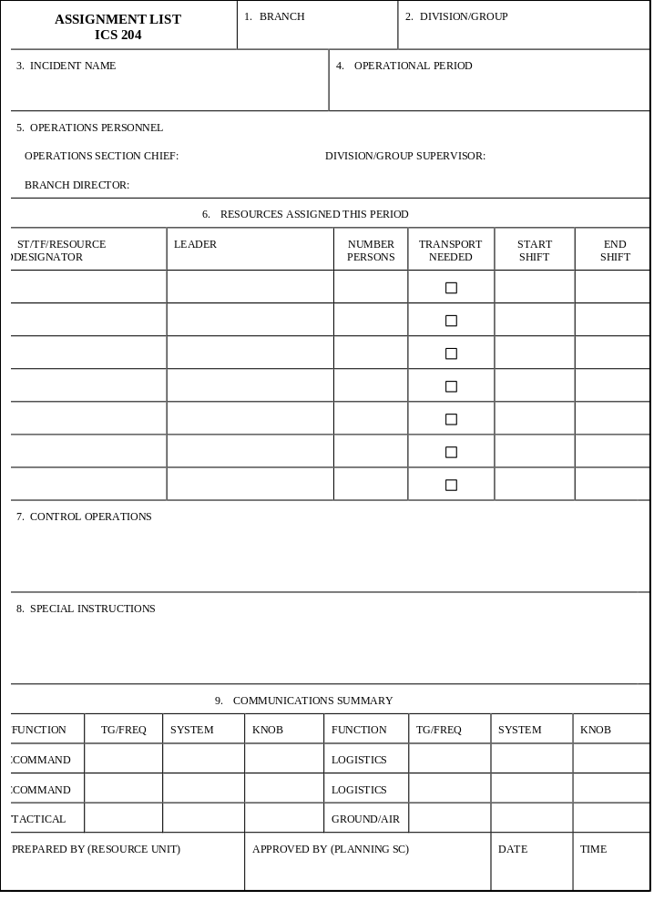

INCIDENT ACTION PLAN COMPONENTS
ICS 204-CONTINGENCY

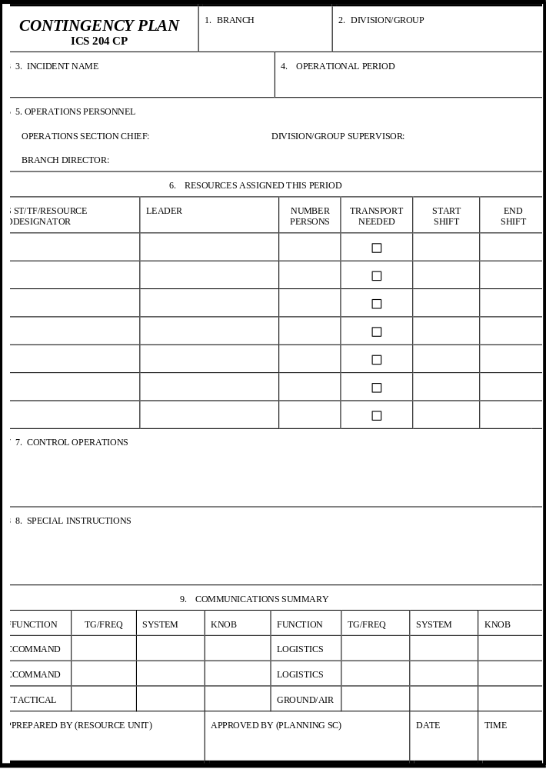

INCIDENT ACTION PLAN COMPONENTS
ICS 205

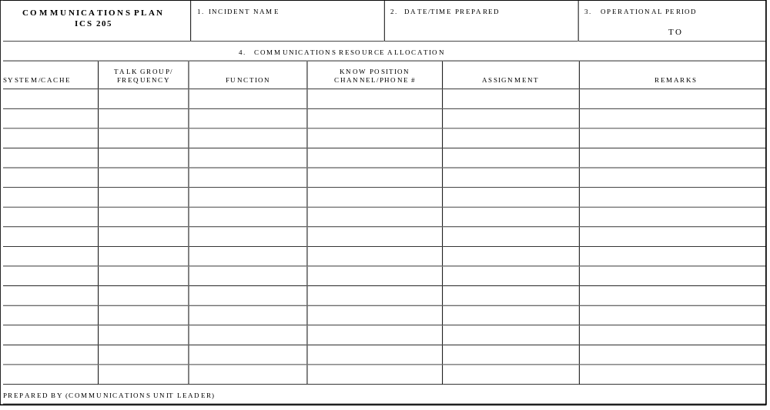

INCIDENT ACTION PLAN COMPONENTS
ICS 206

